Tribal Group
Kings Orchard
One Queen Square
Bristol
BS2 0HQ

24 June 2022

QUALITY MARK

Dear Parents and Carers,

I am delighted that your child’s early years provider has recently been awarded a Quality Mark for Early Years Award.

This national accreditation is awarded to early years providers of any size within the maintained, private, voluntary and independent sector which meet the Quality Mark Standard. Schools can gain a similar Primary or Secondary Quality Mark for their work in English and mathematics. Each Quality Mark award will last for two years, after which a renewal assessment is required.

The Quality Mark for Early Years promotes and supports the development of young children in their communication, language and early mathematical skills. This is achieved through providing investigative learning opportunities suitable for the stage of development each child has reached, with support from skilled practitioners. Such a positive start in their early years gives every child the ‘bedrock’ of a good education and sets them up with the skills they need for their future school and adult lives.

To achieve a Quality Mark a provider must undergo an assessment, carried out by an external accredited assessor, against the 10 ‘Elements’ of the Quality Mark for Early Years framework. These include reviewing young children’s learning needs and planning their next steps, providing safe, stimulating resources and equipment – both indoors and outdoors - and having skilled early years practitioners. Positive partnerships with families and effective monitoring and evaluation are also required - particularly to achieve renewal when continuing development must be demonstrated.

I hope you will share your child’s early years provider’s pride in achieving this award.

Yours faithfully,
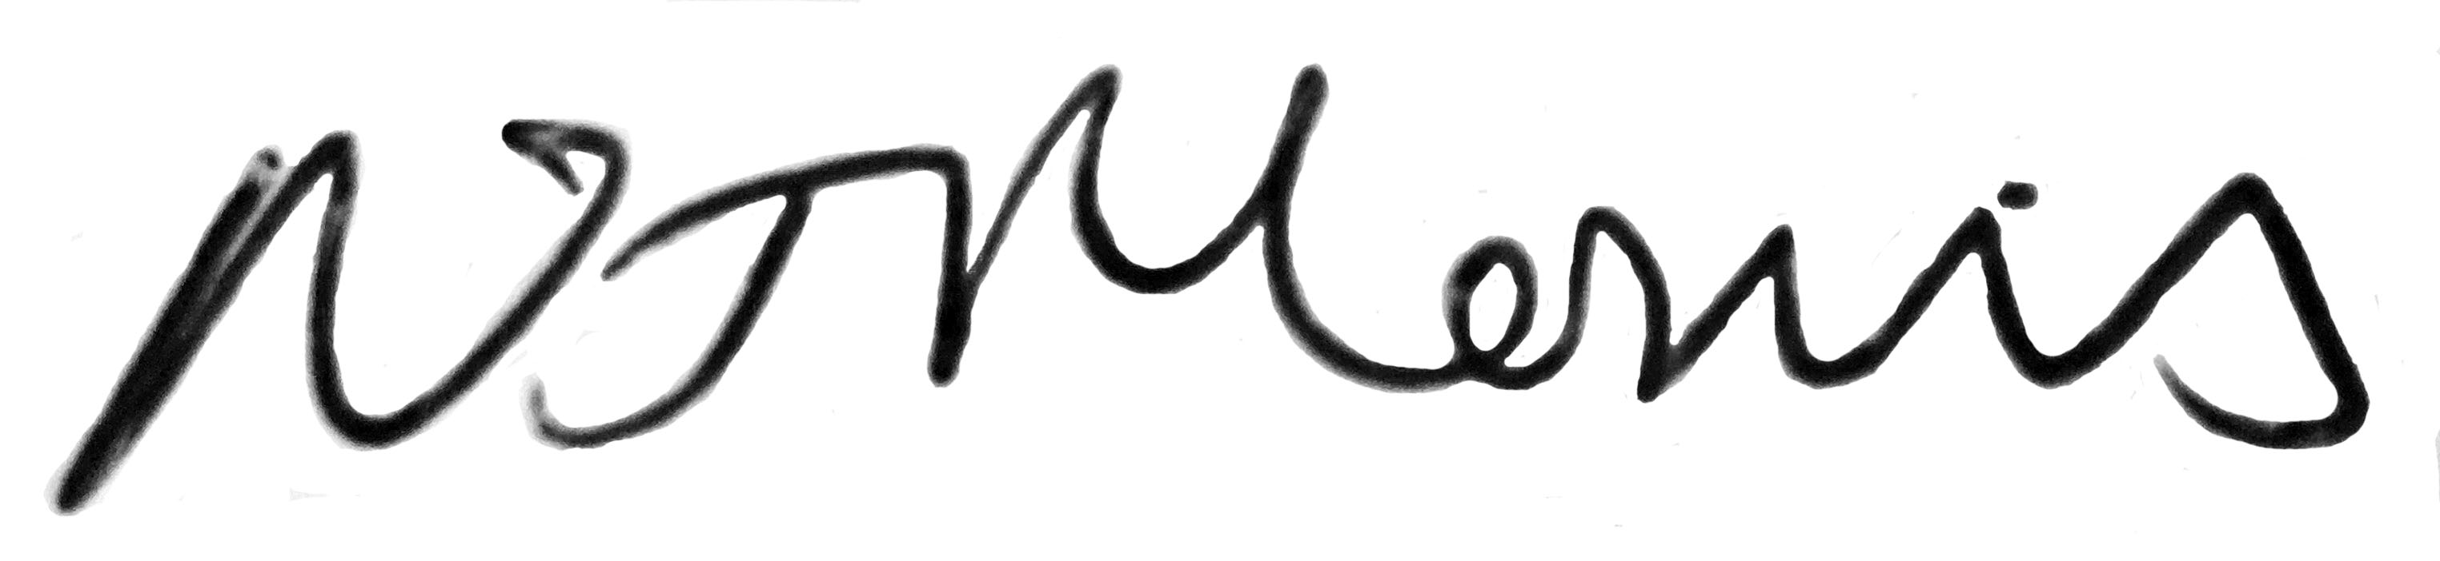
Nicola Morris, Quality Mark National Director

