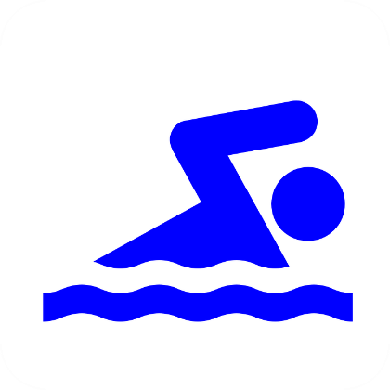

In the 2018/19 academic year we had ONE Year 6 pupil who could pass all of these competency tests and ANOTHER Year 6 pupil who could pass two of the three competency tests which were 'use a range of strokes effectively' and 'can perform safe self-rescue in different water based situations'.

We had TWO Year 4 pupils who could pass all three of the competency tests and we had FOUR Year 5 pupils who could pass all three competency tests.

